**Data Exploration  and Insight:**

Basic Summary about Data:

**Total Content on Netflix : 8807**(Movies + TV Shows)

Available Columns : 12

**Missing Data :**

director 29.908028 %

cast 9.367549 %

country 9.435676 %

# in analysis above missing values are replace with "Unknown" category.

Number of Unique Values per Columns:

show_id 8807

type 2

title 8807

director 4529

cast 7693

country 749

date_added 1767

release_year 74

rating 17

duration 220

listed_in 514

description 8775

**Type of Content On Netflix :**

Movie 69.615079 %

TV Show 30.384921 %

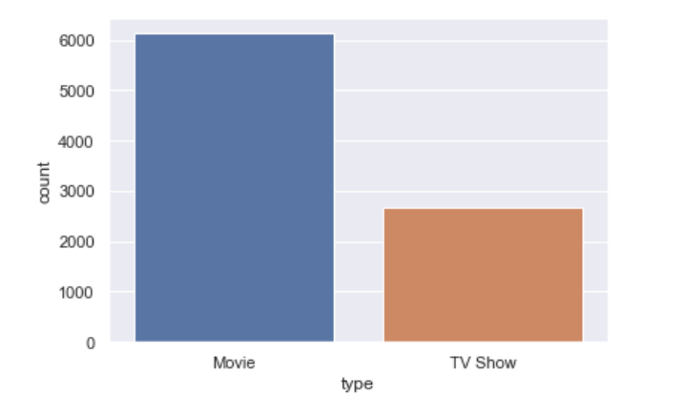

**# Content added per year  :**

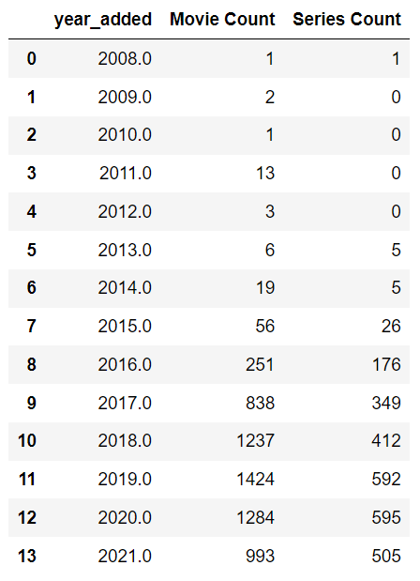

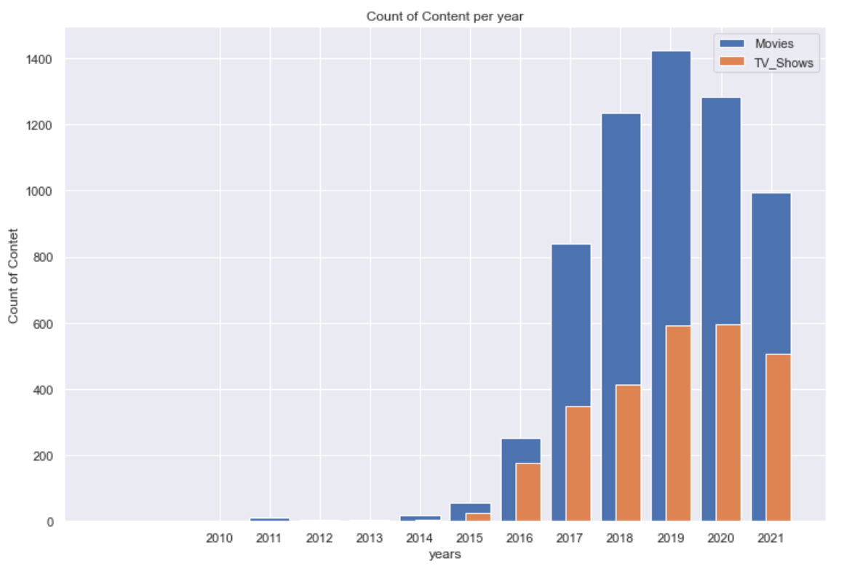

*# here is the comparison of Number of  Content added between years from 2010 to 2021 ,  by Movies and TV Shows!*

*# number of content has been increased from 2014 to 2019 .*

*# after 2019, number of content has been decreased.*

# Number of Content released per Year in Last 30 Years

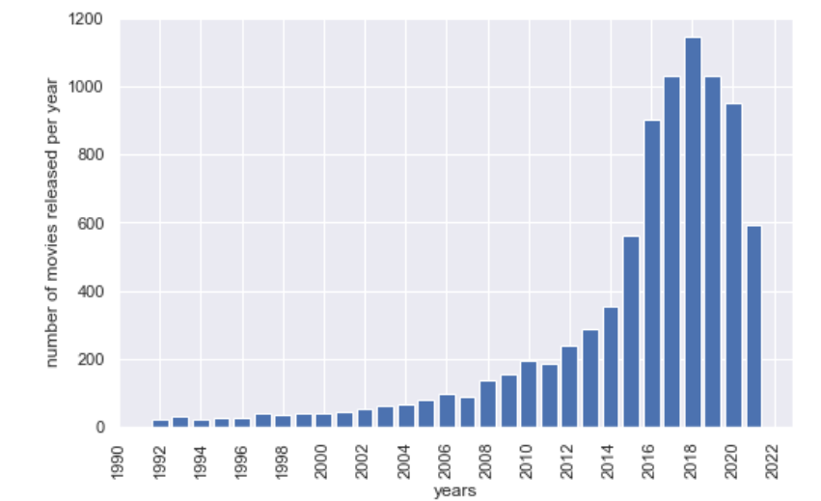

*# possibly because of pandemic , count of releasing movies has been decreased .*

***Recommendation :***

*It would be appropriate decision if we add content based on past data as per best actors and directors , or produce more movies specifically for Netflix .*

**Number of Content Per Rating :**

TV-MA 36.430762 % Adults

TV-14 24.537090 % Teens

TV-PG 9.803476 % Older Kids

R 9.076451 % Adult

PG-13 5.566284 % Teens

TV-Y7 3.794161 % Older Kids

TV-Y 3.487447 % Kids

PG 3.260252 % Older Kids

TV-G 2.499148 % Kids

NR 0.908781 % Adults

G 0.465750 % Kids

there are even more categories of rating , but 99.82% of data falls in above category.

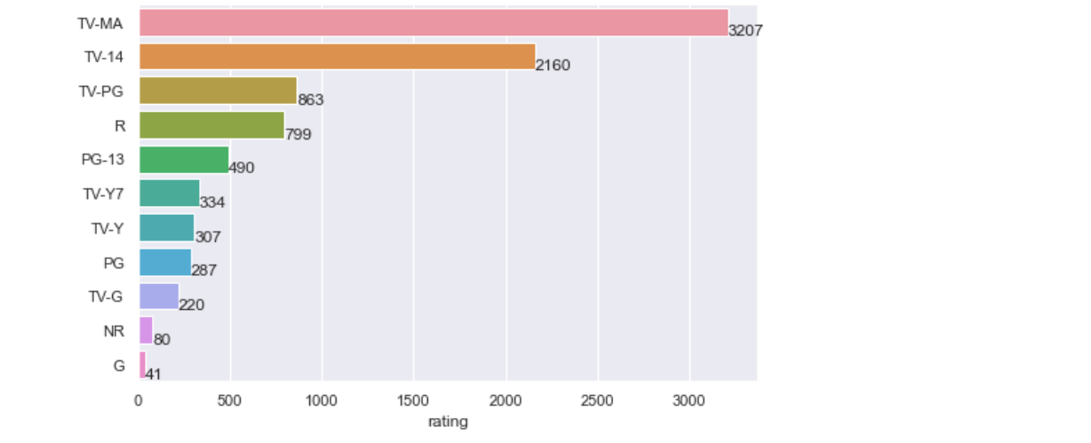

Above categories of Rating are for belove category people:

Adults 46.484153 %

Teens 30.103374 %

Older Kids 16.926048 %

Kids 6.452346 %

*# Majority Content is for Adults and Teens Category*

*# Around 23% content is for kids and older kids.*

**Number of Content per Genre :**

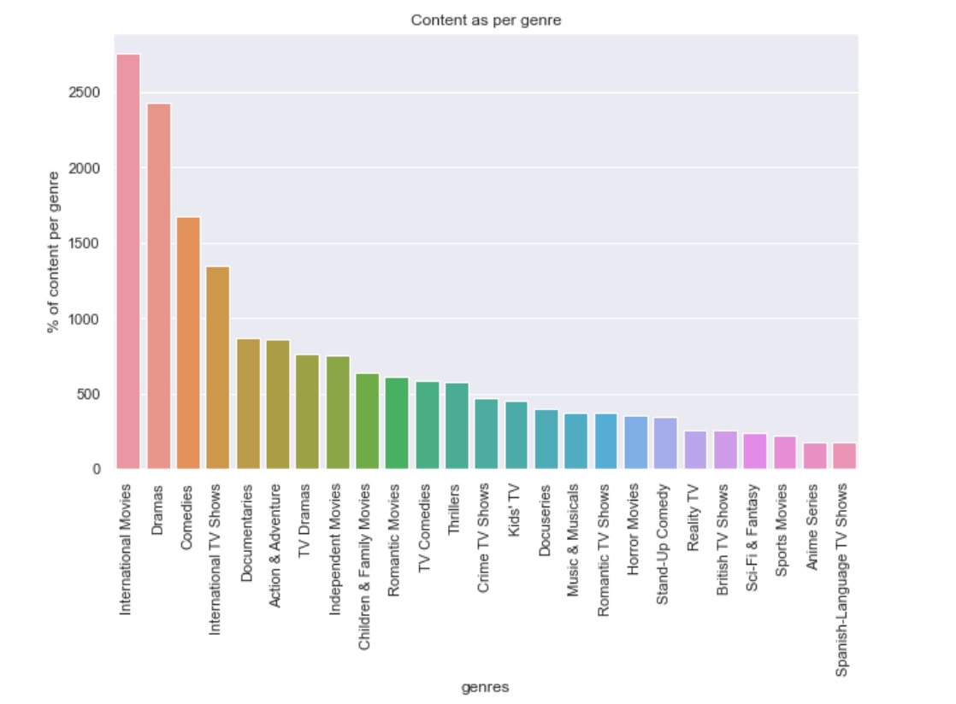

Top 23 Genres Globally watched on Netflix :  (91% of total content are from below category of genres)

International Movies 14.242095 %

Dramas 12.560161 %

Comedies 8.663251 %

International TV Shows 6.991668 %

Documentaries 4.497231 %

Action & Adventure 4.445479 %

TV Dramas 3.948662 %

Independent Movies 3.912436 %

Children & Family Movies 3.317290 %

Romantic Movies 3.187911 %

TV Comedies 3.006779 %

Thrillers 2.986079 %

Crime TV Shows 2.432335 %

Kids' TV 2.334006 %

Docuseries 2.044196 %

Music & Musicals 1.940692 %

Romantic TV Shows 1.914817 %

Horror Movies 1.847539 %

Stand-Up Comedy 1.775087 %

Reality TV 1.319671 %

British TV Shows 1.309320 %

Sci-Fi & Fantasy 1.257569 %

Sports Movies 1.133364 %

**# Currently Number of Content per Country on Netflix :**

United States 3689

India 1046

Unknown 831

United Kingdom 804

Canada 445

France 393

Japan 318

Spain 232

South Korea 231

Germany 226

Mexico 169

China 162

Australia 160

Egypt 117

Turkey 113

Hong Kong 105

Nigeria 103

Italy 100

Brazil 97

Argentina 91

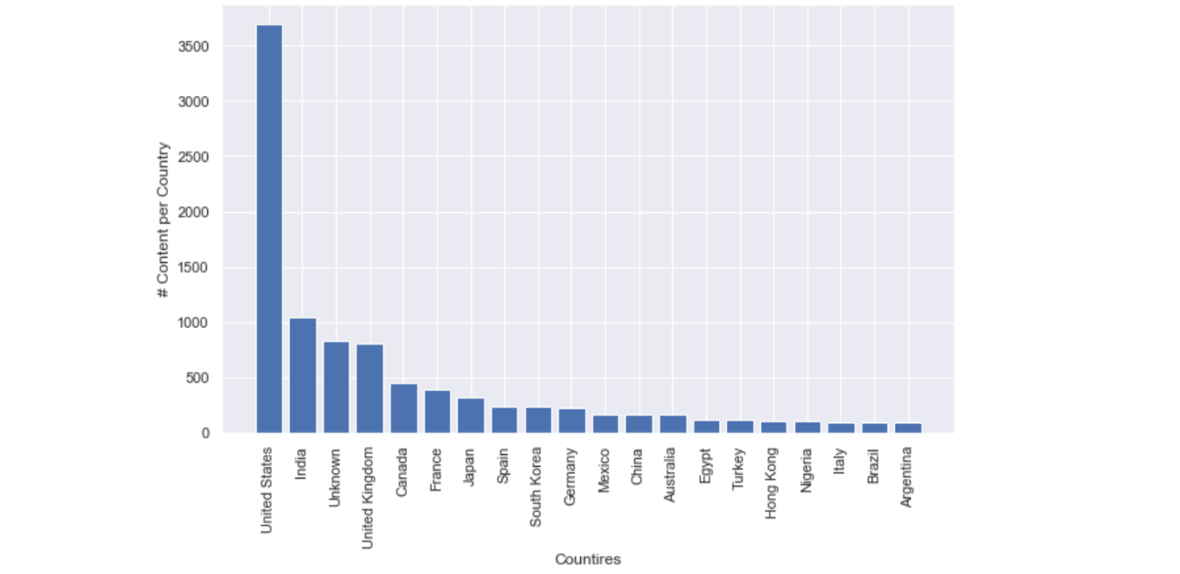

*# 85% of the total Content is from :*

United States 3689

India 1046

Unknown 831

United Kingdom 804

Canada 445

France 393

Japan 318

these countries .

***if we see some counties :***

***like ,***

Russia

China

Germany

South Korea

Mexico

Singapore

Poland

United Arab Emirates

New Zealand

there are some **countries**who have very good **international**presence , and some of them are having more population , means that there can be the **potential customers** from above country list!

**Here are some recommended Actors and Directors who are having their content in maximum counties.**

**directors who have worked Internationally:**

# directors # countries count

Matthew Salleh 12

Joshua Oppenheimer 10

Farhad Safinia 8

Martin Campbell 8

James Watkins 7

Aaron Woodley 7

Renny Harlin 7

Nora Twomey 7

Brian De Palma 7

**Actors who have worked Internationally:**

# actors # countries count

Alfred Molina 14

Paul Giamatti 14

Mads Mikkelsen 13

Ben Whishaw 13

James Franco 13

Eddie Marsan 13

Vincent Tong 13

Sylvester Stallone 13

John Cleese 13

**Top 20 most versatile Actors**

**who have worked in various types/genres of Movies:**

Number of genres per actor   # number of movies they have done

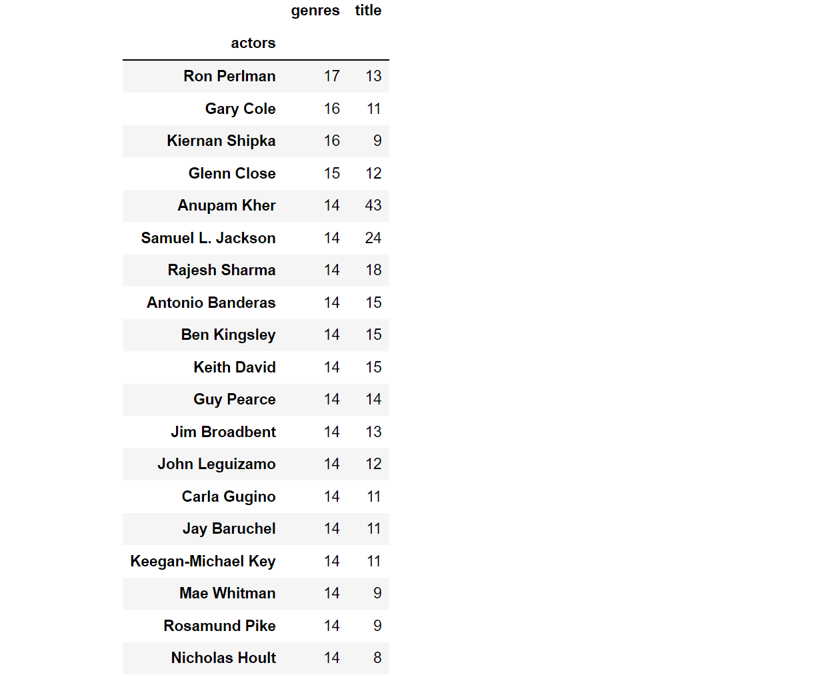

**Top 20 most versatile Directors**

**who have worked in various types/genres of Movies:**

   #number of genres director has worked in # number of movies they have done

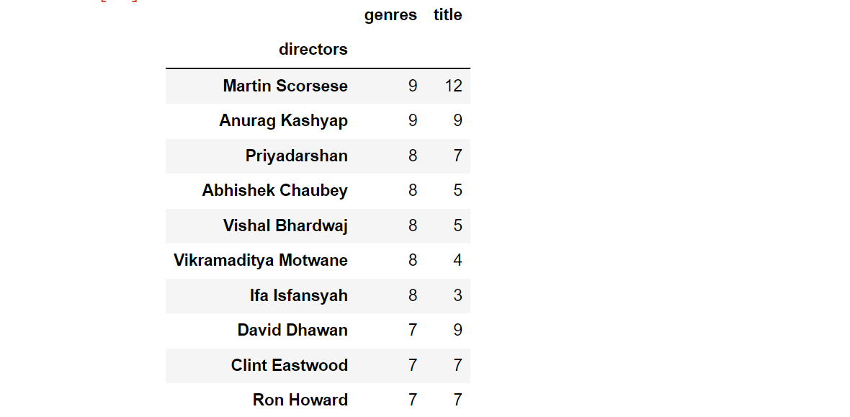

**Change in duration of movies and series over the years :**

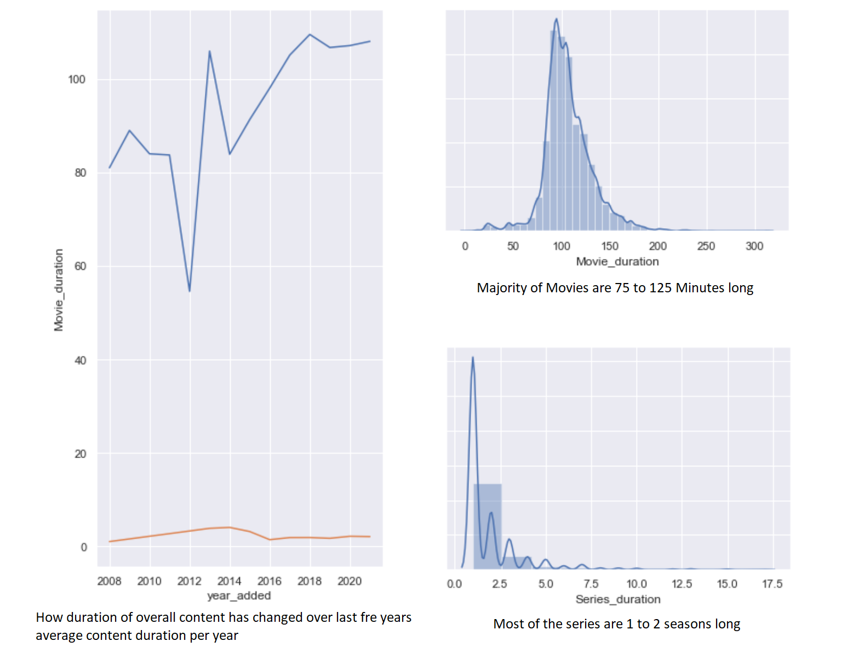

looks like majority of the Movie content is around 75 to 125 min long ! and Series/TV Shows are 1 to 2 seasons long .

adding longer content may or may not be beneficial

**below is the data , for Movies and TV shows with highest duration :**

***# Recommendation :***

 below information can be helpful in increasing the watch time on Netflix by producing/adding their Movies/series.

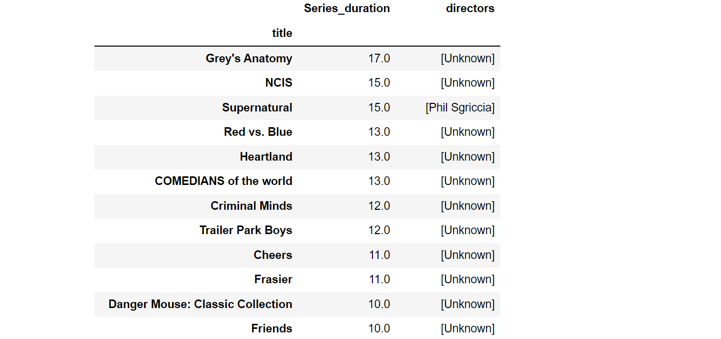

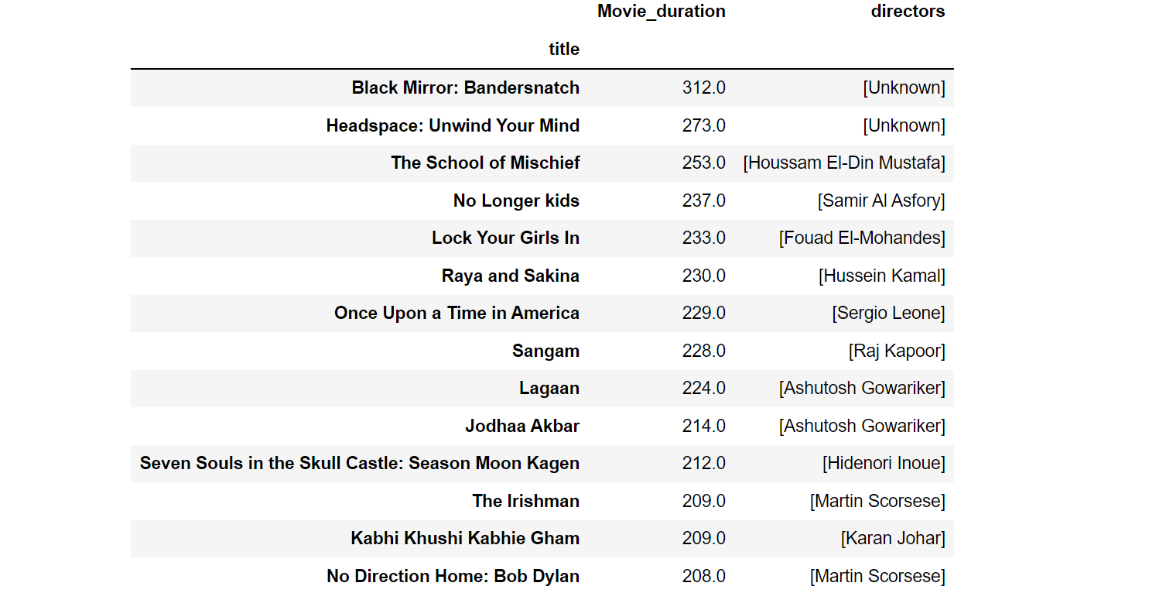

**TV shows And Movie data**

# types of content added on Netflix every year.

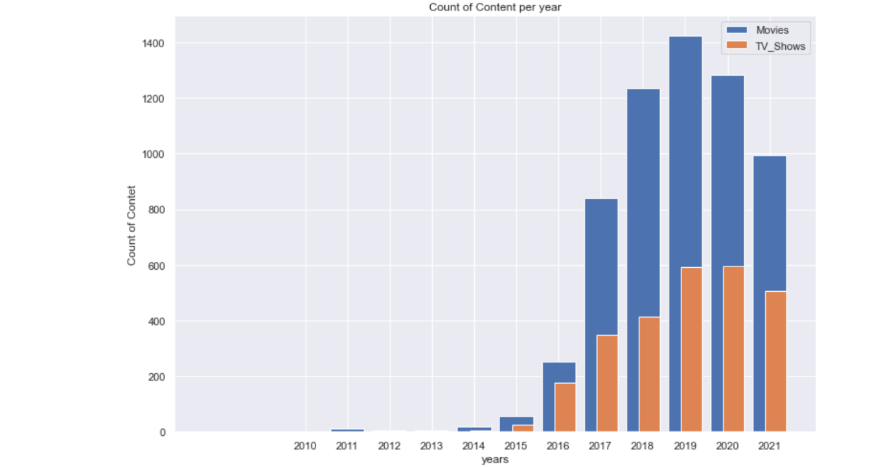

# Netflix  has equal focus on adding movies and tv shows from 2015 .

Tv Shows and Movie counts for top Countries :

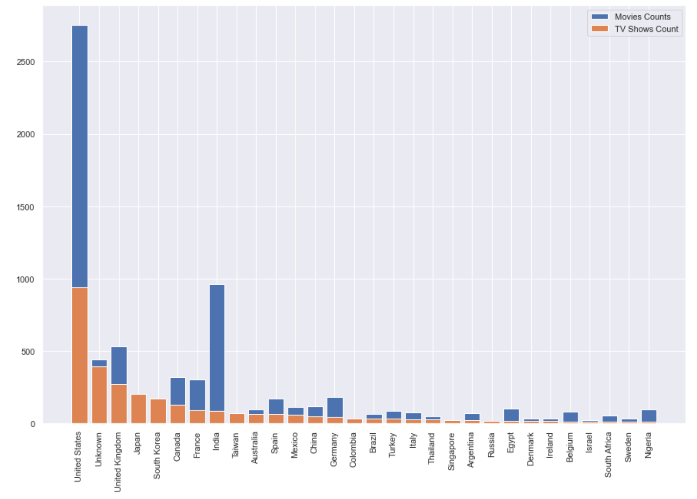

# from above chart:

we can conclude that some countries :

Japan , South Korea , Taiwan , Cambodia , Singapore , Russia

have more tv shows content compare to movies !

***Recommendation :***

Probably people from these counties are more interested in TV Shows than in Movies .

we can take this information into account and recommend to focus on producing or releasing new content for particular movie.

India and Unite States has more content of Movies and for rest of the countries it is equally distributed.

**Best time to release movie/TV Shows :**

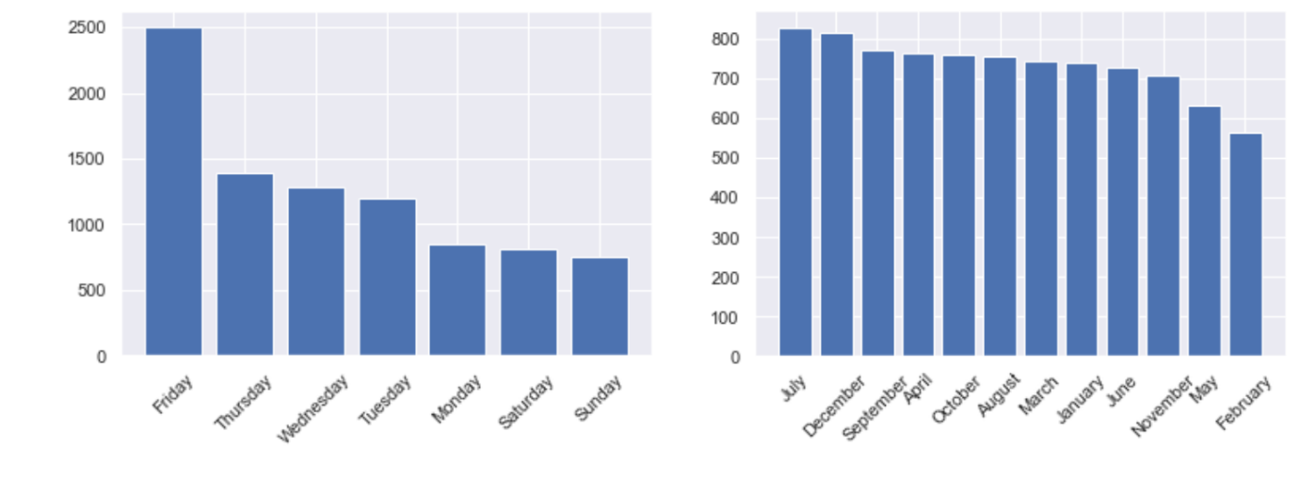

best time to launch/release the new content is :  July , September and December months

on Friday !

**# Recommended  Actors/Directors as per Type of Content :**

*Actors/            # number of*

*Directors             Contents*

# Top 10 actors in TV Shows  :

Takahiro Sakurai 25

Yuki Kaji 19

Junichi Suwabe 17

Daisuke Ono 17

Ai Kayano 17

Yuichi Nakamura 16

Jun Fukuyama 15

Yoshimasa Hosoya 15

David Attenborough 14

Vincent Tong 13

# Top 3 directors in TV Shows:

Ken Burns 3

Alastair Fothergill 3

Stan Lathan 2

# Top 10 Actors in Movies:

Anupam Kher 42

Shah Rukh Khan 35

Naseeruddin Shah 32

Om Puri 30

Akshay Kumar 30

Paresh Rawal 28

Julie Tejwani 28

Amitabh Bachchan 28

Rupa Bhimani 27

Boman Irani 27

# Top 10 directors in Movies:

Rajiv Chilaka 22

Jan Suter 21

Raúl Campos 19

Suhas Kadav 16

Marcus Raboy 15

Jay Karas 15

Cathy Garcia-Molina 13

Martin Scorsese 12

Jay Chapman 12

Youssef Chahine 12

# How We can help Netflix in deciding which type of content to produce and how they can grow the business in different countries : 

# here is the list of Most Popular genres per for Countries having highest users :

<< United States >>

['Comedies', 'Dramas', 'Children & Family Movies']

<< India >>

['International Movies', 'Dramas', 'Comedies']

<< United Kingdom >>

['Dramas', 'British TV Shows', 'International Movies']

<< Canada >>

['Comedies', 'Children & Family Movies', 'Dramas']

<< France >>

['International Movies', 'Dramas', 'Independent Movies']

<< Japan >>

['International TV Shows', 'Anime Series', 'Action & Adventure']

<< Spain >>

['International Movies', 'Dramas', 'International TV Shows']

<< South Korea >>

['International TV Shows', 'Korean TV Shows', 'Romantic TV Shows']

<< Germany >>

['Dramas', 'International Movies', 'Comedies']

<< Mexico >>

['Spanish-Language TV Shows', 'International Movies',

'International TV Shows']

**Top Genres / Actors / Directors from USA, that we can recommend based on their Content Counts :**

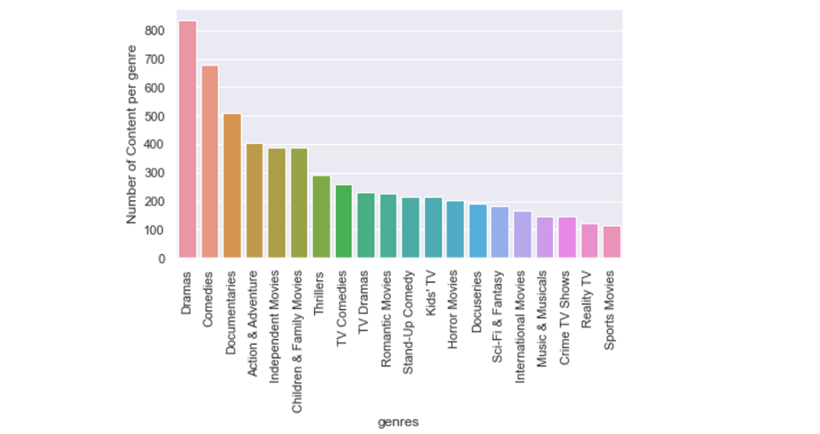

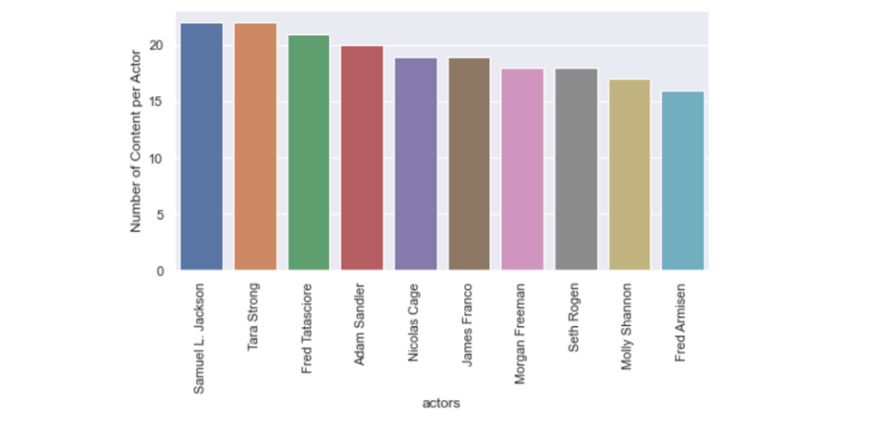

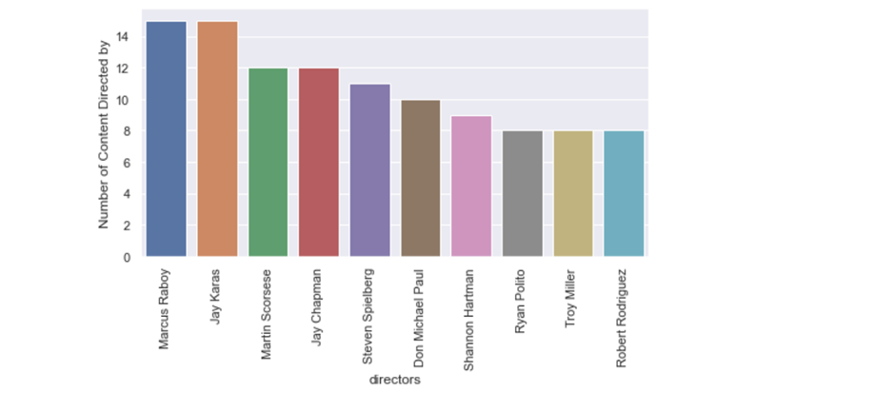

**Top Genres / Actors / Directors from India, that we can recommend based on their Content Counts :**

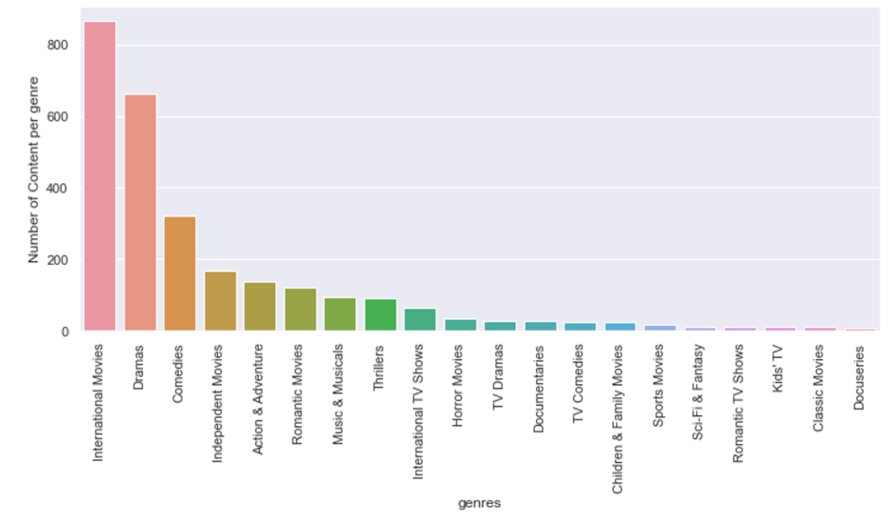

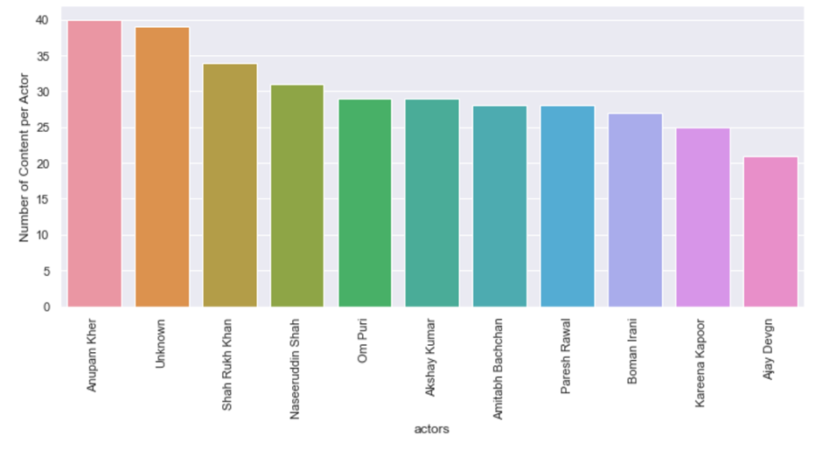

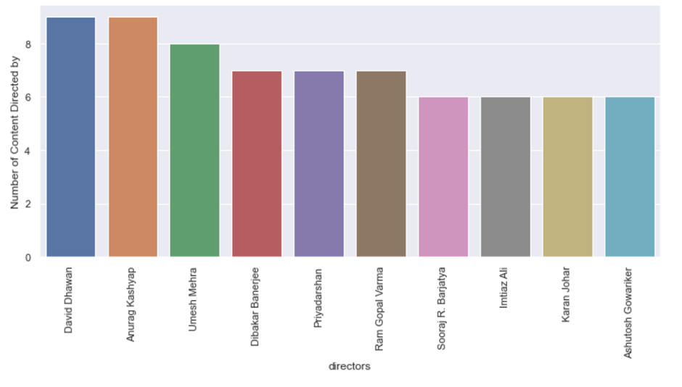

**Top Genres / Actors / Directors from UK, that we can recommend based on their Content Counts :**

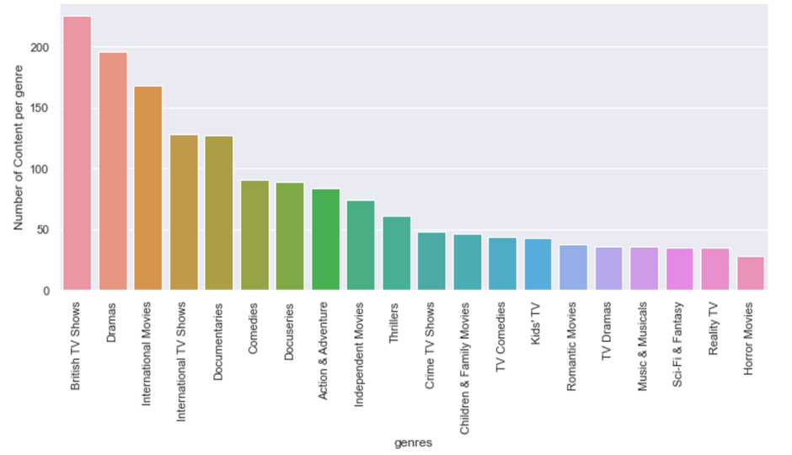

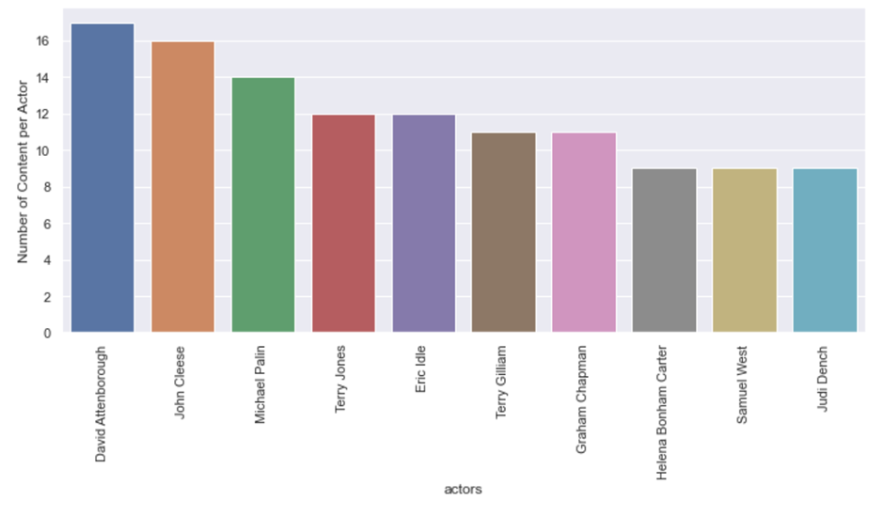

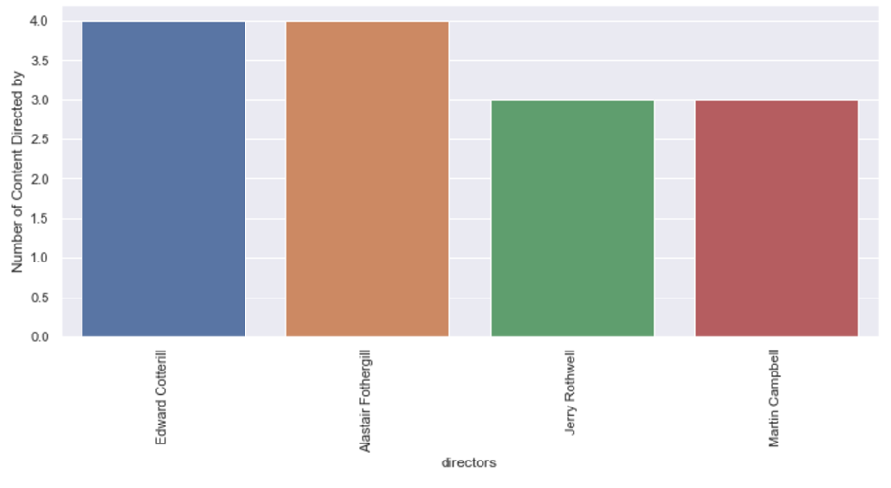

Apart from Highest Subscribers Countries :

**People from other countries can be potentials subscribers :**

**Those countries are :**

Russia

China

Germany

South Korea

Mexico

Singapore

Poland

United Arab Emirates

New Zealand

*Recommend to release or produce the content from below list :*

*Lists Contains best Actors , directors and most preferred genre by the countries above listed.*

*which can help get new subscribers and grow in business in those particular countries.*

*Some countries out of these lists , have a good international  cities like, Dubai , Auckland, Beijing , Frankfurt etc . and some are very high population , there can be great potential subscribers from those cities :*

